(You may insert your own logo and site details)
Allotment Composting

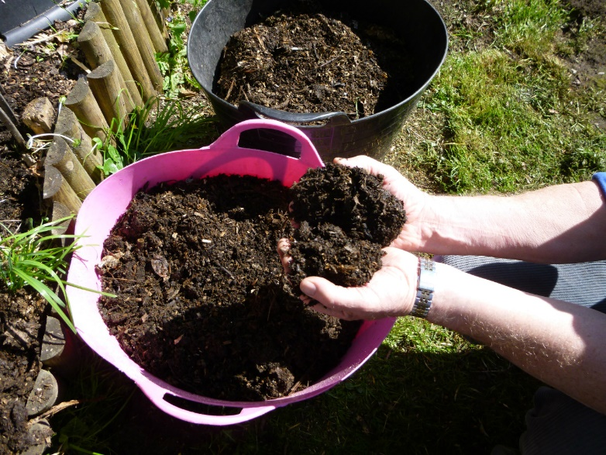
Composting is a natural process that can convert garden waste into a material that can be used as a soil improver, mulch, or to top up raised beds or flower pots. It can also be used to make seed or potting compost and a liquid feed. It has the additional advantage of diverting waste from landfill and saving the cost of collection by the local authority. It is safe to assume that if you are reading this page you either already compost or are interested in composting.
Allotment organic waste suitable for composting includes grass cuttings, trimmed leaves from vegetables, annual weeds (without seeds), tree leaves, small twigs and vegetable plants at the end of their season. It can also include items specifically grown to compost such as comfrey
There are two main types of composting.
Cold Composting
In cold composting the material is put in a bin or heap as it becomes available and left to decompose slowly with the contents being turned occasionally to aerate the material. Using this method, it can take a year or eighteen months to produce compost. On allotments bins made from four pallets or the Dalek bins obtained under council schemes are normally used when cold composting. Most of us now use cold composting techniques on the allotment in a plastic bin. Cold composting does not destroy pathogens which means that plants with diseases that can survive in soil away from the plant, should not be composted using these techniques. Plastic bins have lids, pallet bins should be covered with a heavy plastic sheet or tarpaulin to stop the contents drying out in the summer and becoming water clogged during wet periods.
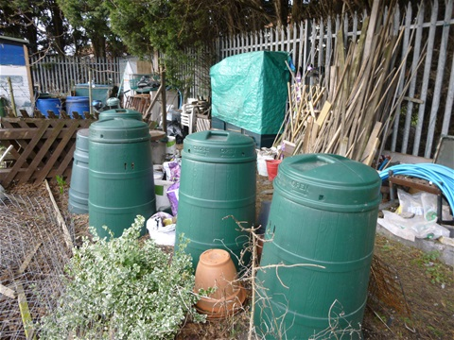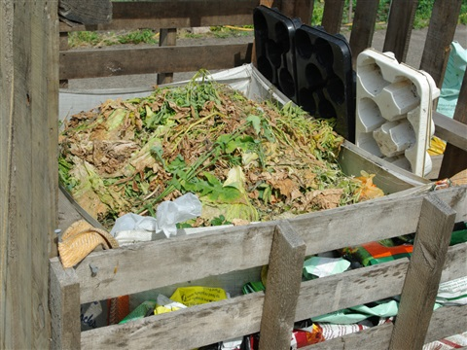
Plastic bins on an allotment | A basic pallet bin

Hot Composting.
Hot composting can produce compost in three to ten weeks, but it requires active management of the heap. The material needs to be cut into small pieces, added to the bin all in one batch and the heap turned regularly i.e. every two or three days for the first couple of weeks. It is usually to use a bank of three or four bins for this technique with the material being moved from bin to bin as it is turned to allow access of more air. As it requires much more effort and time than cold composting it is not as frequently used as the cold composting techniques. (More information can be found at www, carryoncomposting.com). Hot composting will kill weed seeds and pathogens (diseases).
In this introduction to composting on the allotment we will only consider cold composting.

Locating the bins
If plastic bins are used, they should be protected from prevailing winds to prevent them or their lids blowing away in storms and the contents drying out during the summer. The composting area should be located away from water courses or drains leading to any stream to prevent leachate entering the watercourse. The general advice is, if given the choice, do not to locate a compost bin directly under trees and certainly not under conifers. Some say that birch and elder are fine.
Balancing Greens and Browns
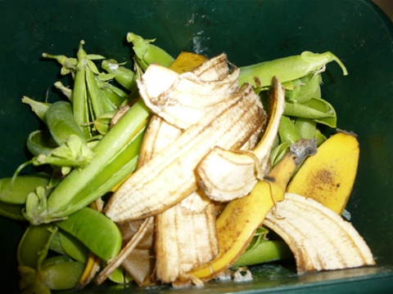
“Compost happens” (and if you search the net you can buy the t-shirt) but it only happens due to the work of millions of compost creatures from bacteria and fungi to worms. Like all creatures they need food and the right conditions e.g. warmth air and water to and turn the waste organic matter into friable earthy compost. The compost creatures need a source of nitrogen and carbon.
We divide compostable materials into two main groups Greens and Browns. The Greens are a good source of Nitrogen having a low Carbon: Nitrogen ratio.

Greens
High in nitrogen, they also tend to contain most moisture. They provide nutrients and moisture for the compost workforce. Examples of greens from the garden include vegetable "tops", grass mowing’s, nettles, comfrey, annual weeds and old vegetable plants. Greens decompose quickly.

Browns
High in carbon the Browns decompose more slowly and provides the energy source for the microbes that carryout the composting process.
Browns also provide the means of absorbing excess moisture that would be produced if greens were composted alone. The browns facilitate air-flow within the heap to enable the activity of aerobe organisms within the pile. If it is low in browns and it becomes a compacted mess which air cannot penetrate anaerobic micro-organisms take over and produce a smelly mess often found if too much grass is composted. Examples of browns include cardboard and shredded computer paper from the, old potato, pea and bean plants, stems of brassicas and hedge clippings (preferably shredded).
There are various methods for calculating the Green: Brown ratio but for home composting the current advice is to use about equal amounts of Greens and Browns. Garden Browns include: Tough vegetable or flower stems, old bedding plants, shredded or small pieces of hedge clippings and old straw can be considered as a single group containing material that is slow to rot. In the case of Greens waste it can be helpful to sub-divided the Greens into two groups so that the quantity of Browns to be added can be adjusted to prevent the Greens becoming wet and smelly. Group one which need more Browns consists of those that rot quickly e.g. grass clippings, comfrey, nettles, young annual weeds and plants, and poultry manure. The second group which only need equal quantities of Browns take a little longer to decompose and includes coffee grounds, cut flowers, vegetable leaves and trimmings, rhubarb leaves, soft hedge clippings
Starting at the Bottom
Providing a good airflow to ensure aerobic composting will help the composting process. Adding twigs to the bottom 6” of a bin placed directly on the soil is an effective way of achieving this, coarse “Browns” such as straw, corrugated cardboard), scrunched up cardboard boxes can be used as an alternative. Good airflow can also be achieved by standing the pile or bin on a pallet base, however this may restrict access by worms if there is a gap of 6” across the whole of the base so you might consider filling parts of the pallet with earth.
It helps if the material being put in the bin is layered using alternative layers of browns and greens. This is not so important with modern cold composting systems but even if you are just going to chuck waste in as it arises it is good to start with a layer of browns. Once you get going you can adjust by eye i.e. if it is too dry add greens if too wet add browns
Next add a layer of Greens. Continue as adding material as waste becomes available it is not necessary to add separate layers of greens and browns (aerating the heap or bin will mix them anyway so if you find adding a mix of greens and browns as they become available do so) but whatever you do you need to keep the ratio of greens and browns right otherwise the material will become wet, black and smelly, of just sit in a dry plie doing nothing other than providing a dry home to rats and mice. You can keep the number of flies and other insects to a minimum by always having a layer of Browns at the top of the bin.
Moisture Content
Check the moisture content of the bin by taking a handful of material and squeezing it. It should be moist like a wrung-out sponge. If water runs down your arm it is to wet add Browns. If it is to dry add Greens, water of compost tea.
Harvesting
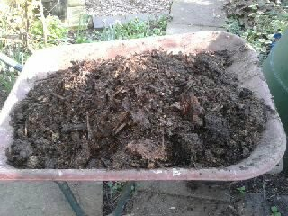
If you are happy to wait a year or 18 months compost will indeed just happen in the bottom of the pile. If you need a quicker turn round because of lack of space, more time to manage the system or a modern bin which provides some form of insulation and aeration you could have compost in a couple of months. Aerating the bin or heap will speed the process and depending on your choice of bin this can be down manually by forking, manually but with less effort using an aerator in a modern bin or by tumbling or rotating the bin.
If you have a wooden bin with a removable front or a plastic bin with a large opening at the base it is easy to inspect and remove the finished compost. If the bin only has a small hatch and no base it may be easier to lift the bin off the compost. The top layers of material will not have composted and should be returned to the bin.
Ensure that the material returned to the bin is mixed well (aerated) and add water if it was dry. Some composters use this process of removing the bin, mixing the compost and returning it to the bin at regular intervals to aerate the contents and speed up the composting process.

Rod Weston
www.carryoncomposting.com

